Process for Non-Cooper Employee to Complete the Security and Confidentiality form via DocuSign

- Click this link - https://na4.docusign.net/Member/PowerFormSigning.aspx?PowerFormId=540c1179-5366-418b-996f-fab2e253a19c&env=na4&acct=7c5dbd19-efc5-4e85-9fcd-4a705f0b4b33&v=2
- Complete the fields below:
  - Enter your name and work email address in the Non-Employee fields
  - For the CUHC Information section use:
    - Name: Dave Owens
    - Email: Hyland-Patrick@cooperhealth.edu (This is the correct email address to use, Patrick is processing these documents on the behalf of Dave Owens)
  - Click “Send Form”

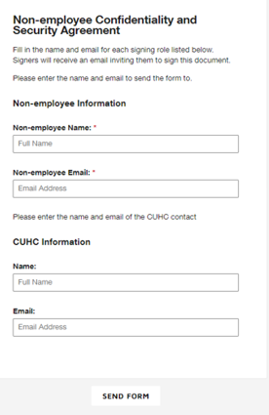
Your name and work email address

Dave Owens
Hyland-Patrick@cooperhealth.edu
- You will be prompted to complete the Security and Confidentiality Form in an online document.
  - For HIPAA and Cyber Security Training, enter “Litmos” as the name of the training and the date that you completed that training.
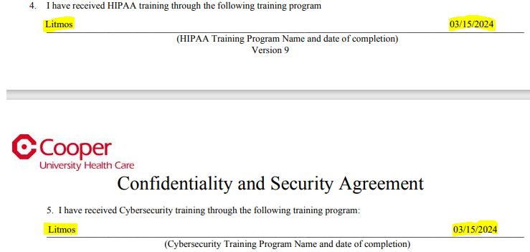
  - For the ROLE field, please use one of the options below. If your role is not listed, please talk to your URG manager to help you decide which role to select.
    - Tech Aide
    - IT Project manager
    - Front Desk/Scheduler
    - Medical Records Coordinator
    - Patient Financial Services
    - Pre-Authorization Coordinator
    - Radiologist
    - Registered Nurse (Cherry Hill Only)
    - Technologist (non-invasive or invasive)
    - Technologist/Supervisor/Lead
    - Breast Care Coordinator/Lung Screening Coordinator
- Once you have completed the mandatory fields, click “Submit”.
- The Cooper team will process your request as quickly as possible which will route the next actions to our IT teams who will complete the necessary steps to provide the appropriate access.
- Users will be emailed their login and temporary password information typically within 3 business days.
- Should a user be unable to access the system when using their login or password, or if they do not recall their password, they must contact the Cooper IT Help Desk at (856) 968-7166.

